1. **Create a VPC.**
2. **Create an Internet Gateway and attach it to the VPC.**
3. **Create two public subnets: one in Availability Zone 2a and another in 2b. Also, create a private subnet in 2a.**
4. **Create a route table**
5. **Associate the Internet Gateway, and link it to the public subnets in Availability Zones 2a and 2b.**
6. **Create a NAT Gateway using the public subnet in AZ 2a.**
7. **Create a route table for the private subnet in AZ 2a**
8. **Associate it with the NAT Gateway and private subnet 2a**
9. **Create a security group with inbound rules for SSH and HTTP access.**

**This document has screenshot from below steps**

1. Launch an EC2 instance in the public subnet in AZ 2a and another EC2 instance in the private subnet in AZ 2a.
   1. Access instance created on private subnet through instance created on public subnet.
   2. Install Apache webserver on private server using below commands
2. *sudo su*
3. *sudo yum install httpd -y*
4. *sudo systemctl start httpd*
5. *sudo systemctl enable httpd*
6. *cd /var/www/html*
7. *vi index.html*
8. *add blow html code*

*<h1>Welcome </h1>*

1. *ESC then :wq*
2. *Hit enter*
3. Create a target group and add the private instance in AZ 2a.
4. Set up a Load Balancer with Availability Zones 2a and 2b.
5. Copy the DNS name of the Load Balancer and open it in an internet browser.
6. If all configurations are correct, the index home page should be displayed.

**Steps to Launch an Instance in a Public Subnet in Availability Zone 2a**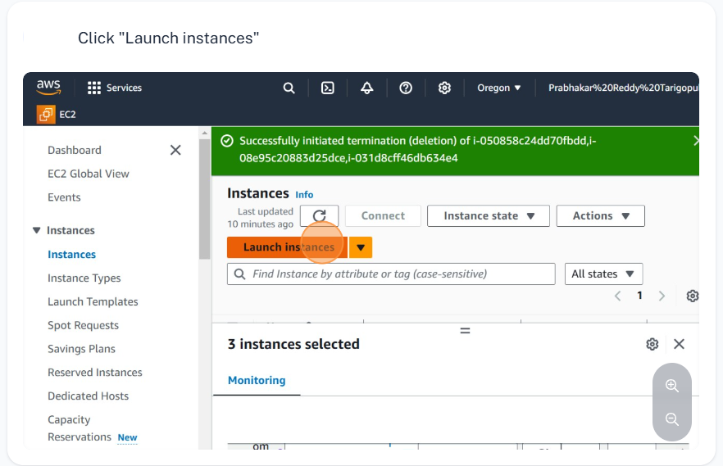

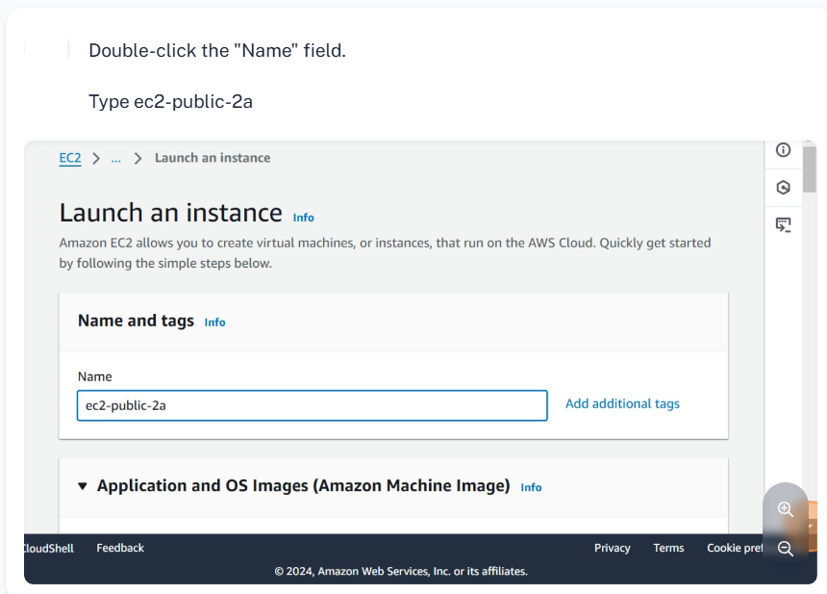

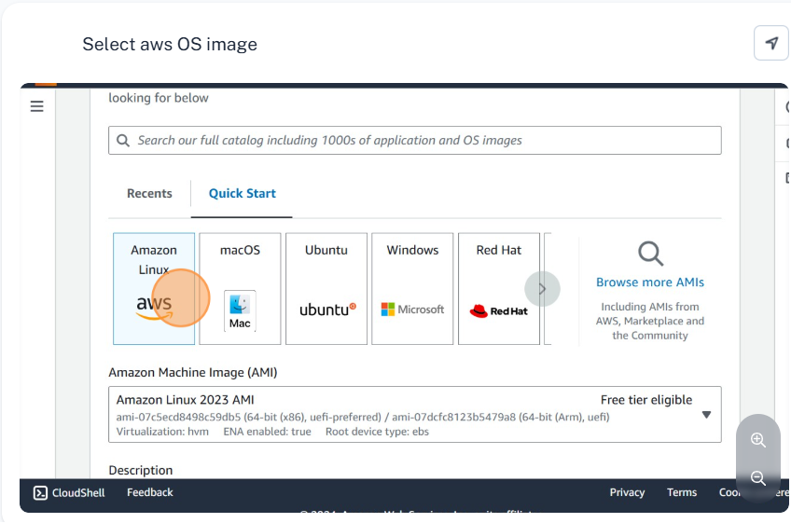

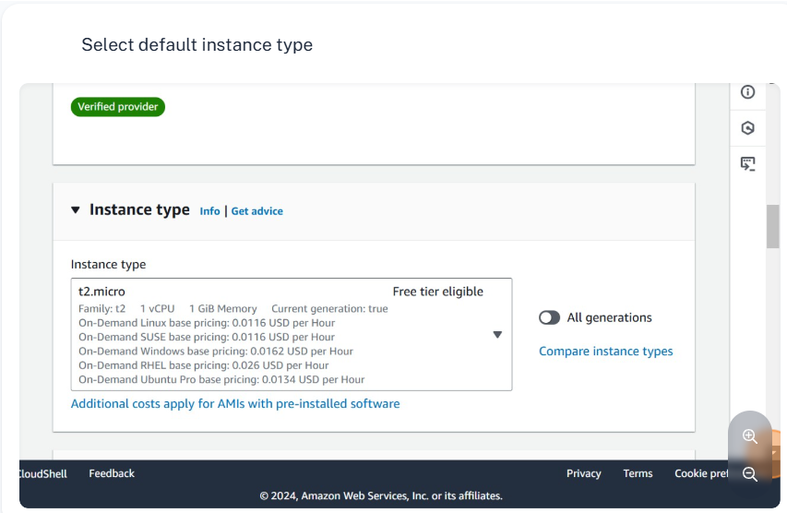

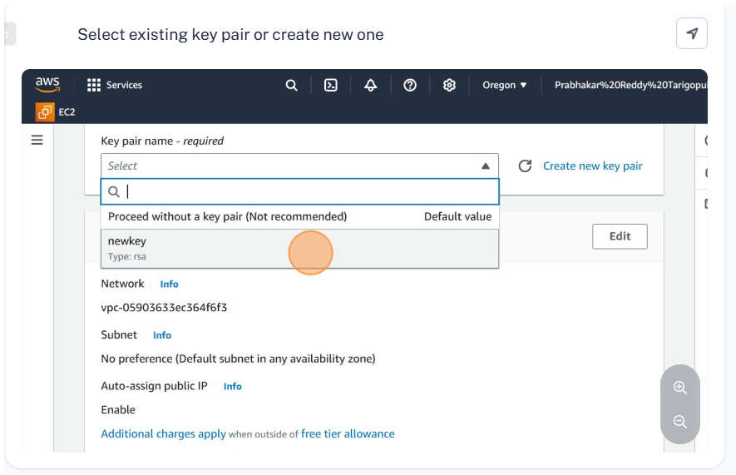

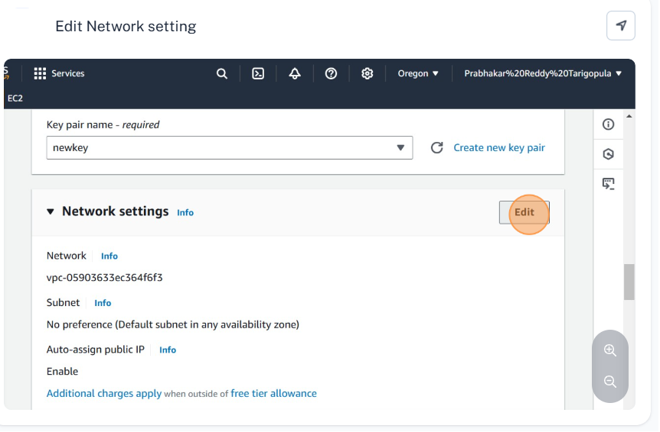

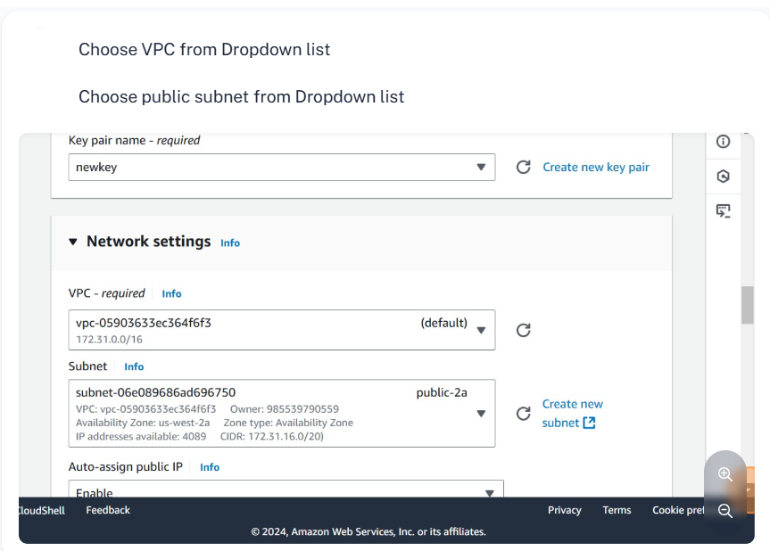

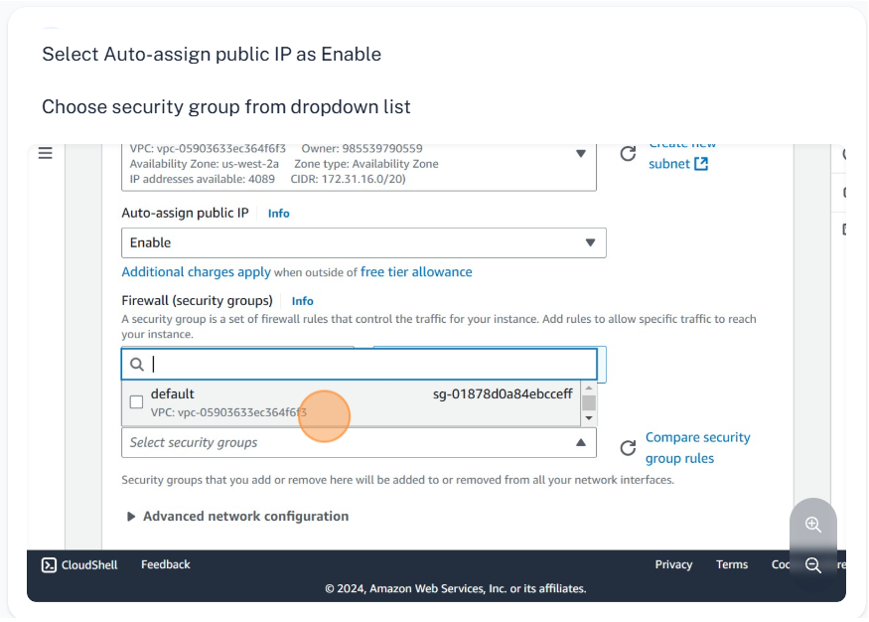

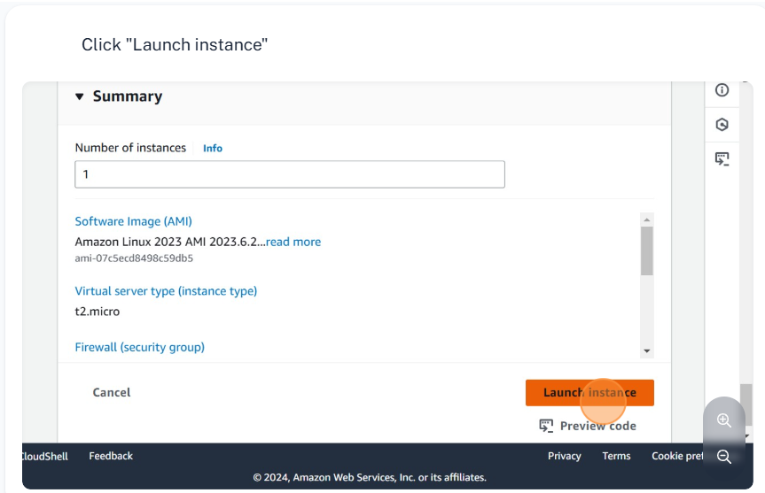

**Steps to Launch an Instance in a private Subnet in Availability Zone 2a**

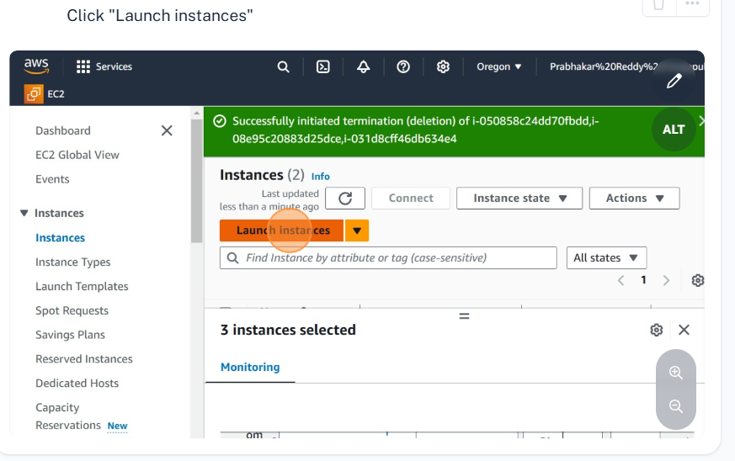

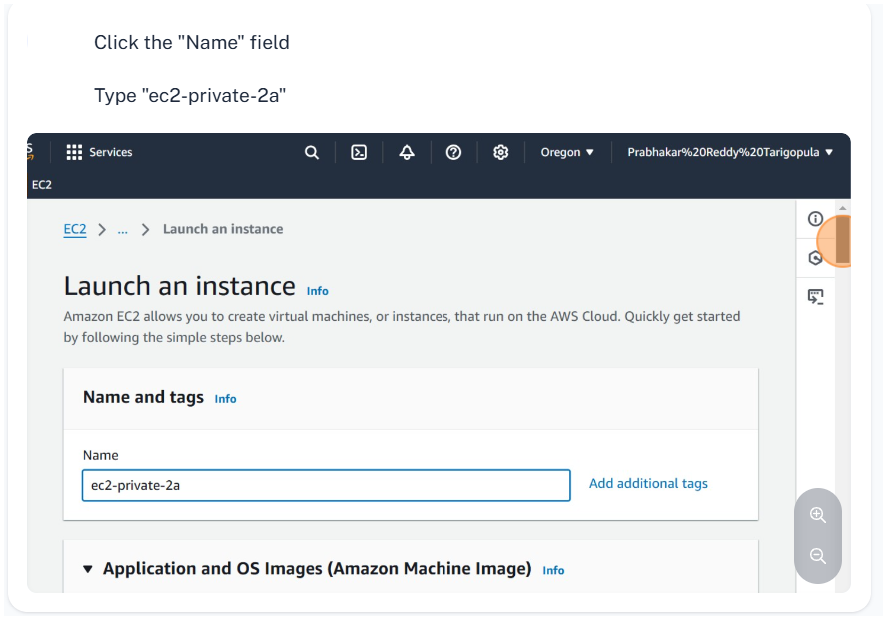

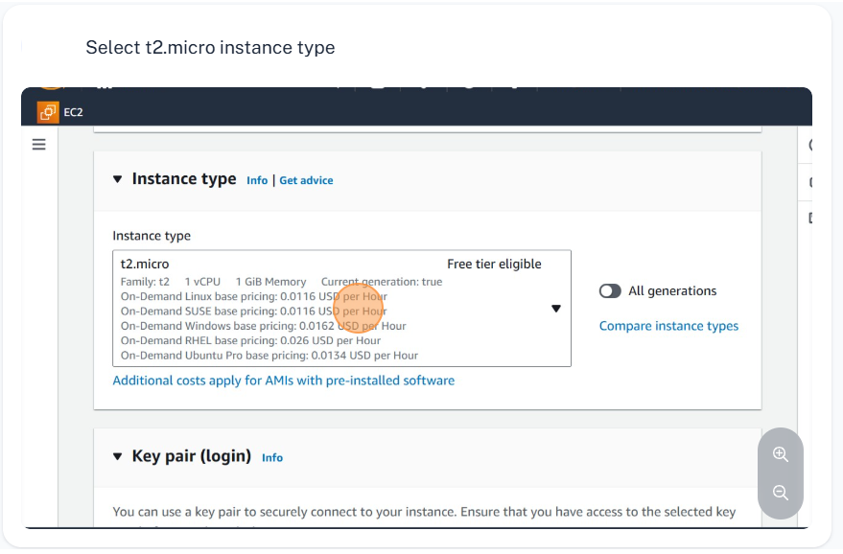

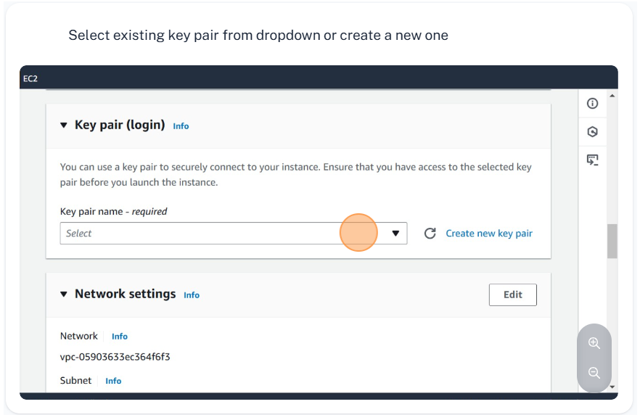

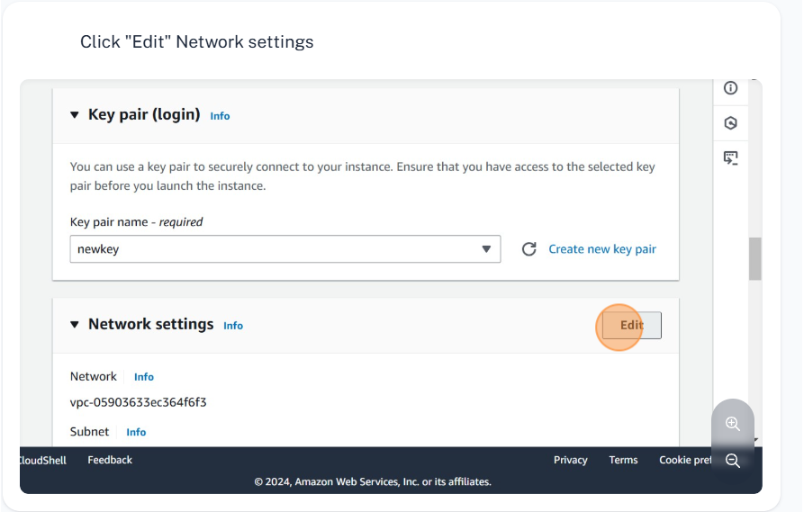

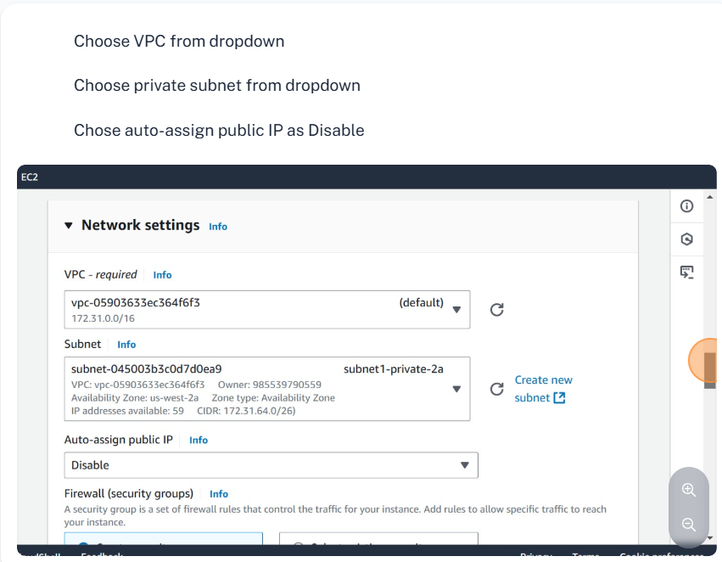

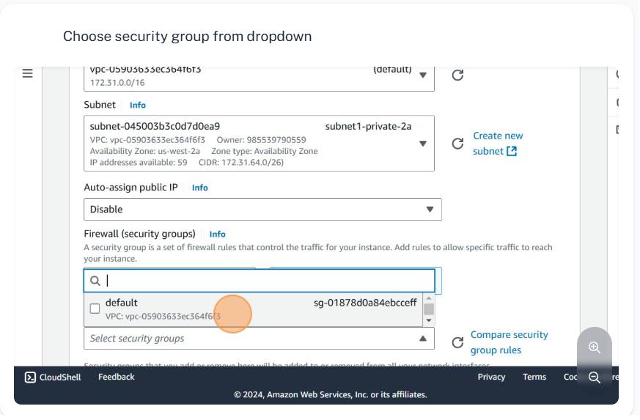

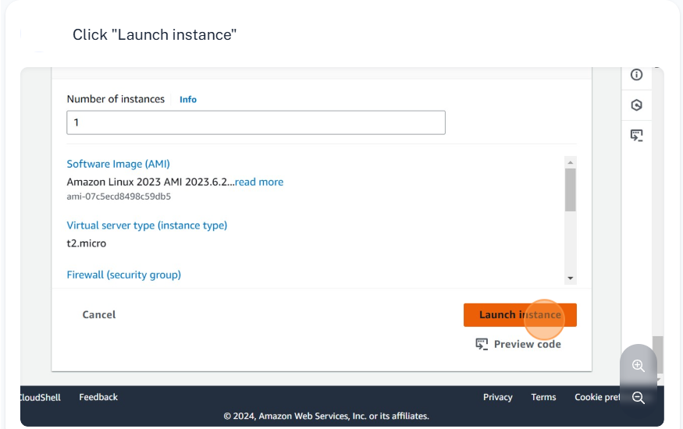

**Steps to Install Apache webserver on private Instance**

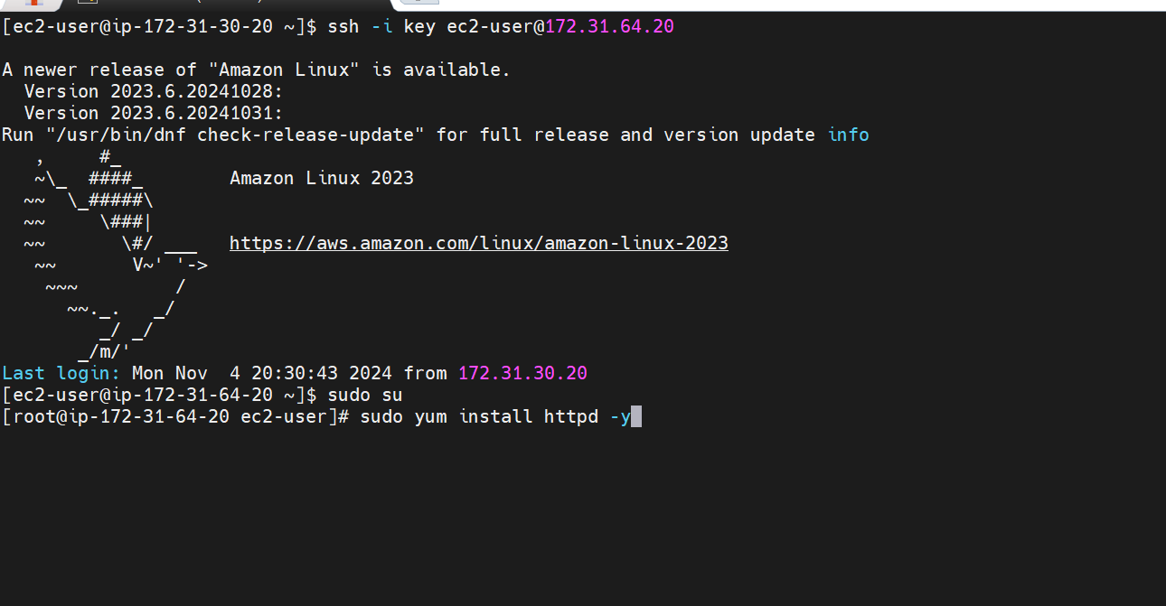

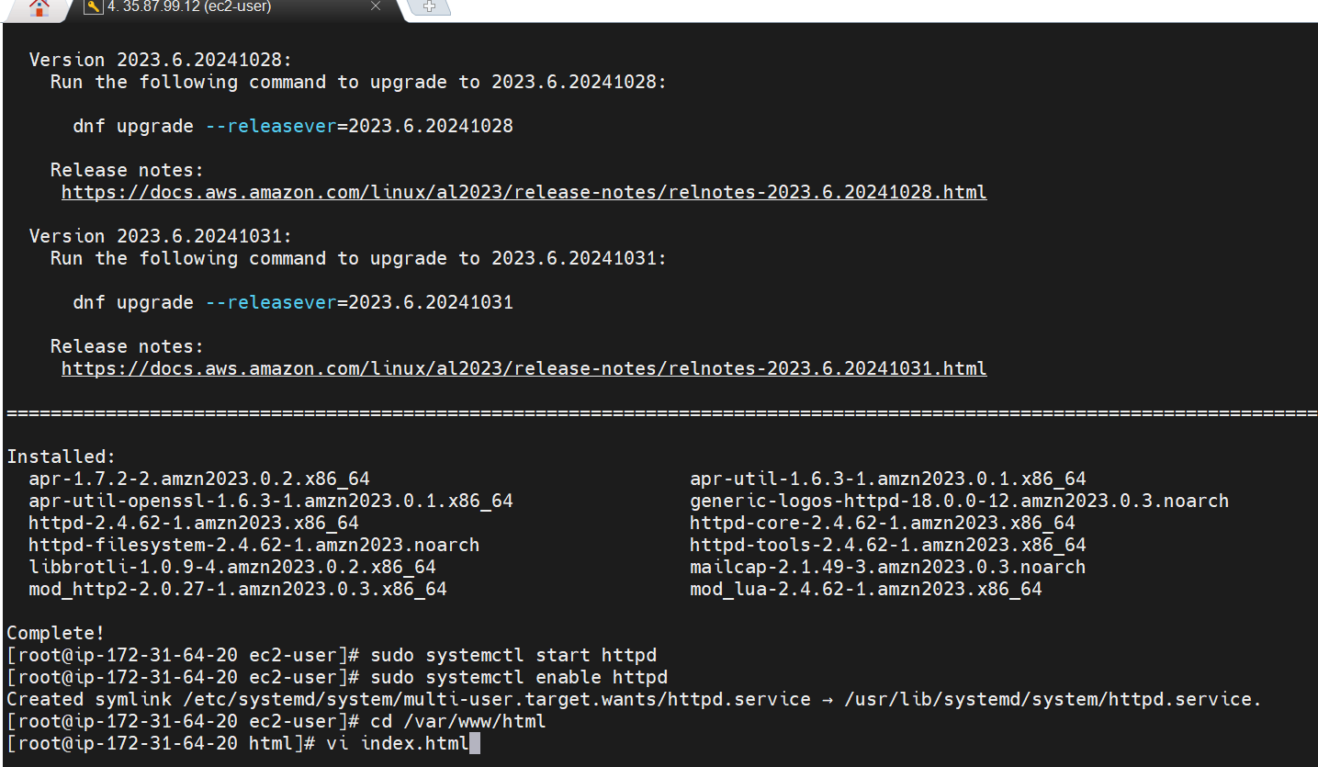



**Steps to configure target group**

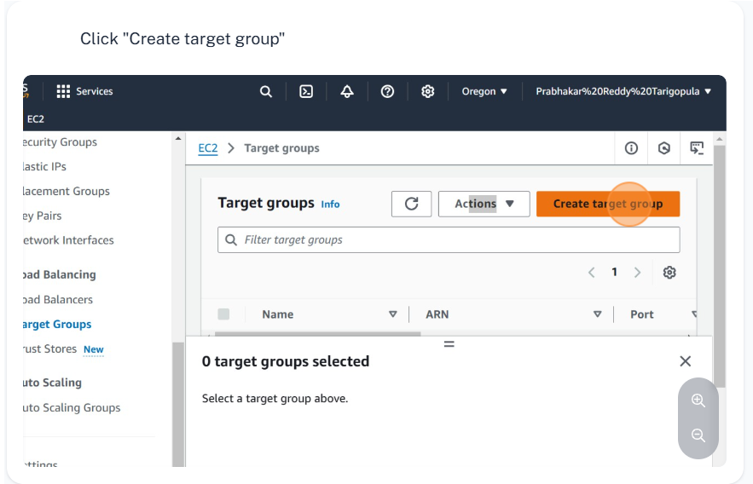

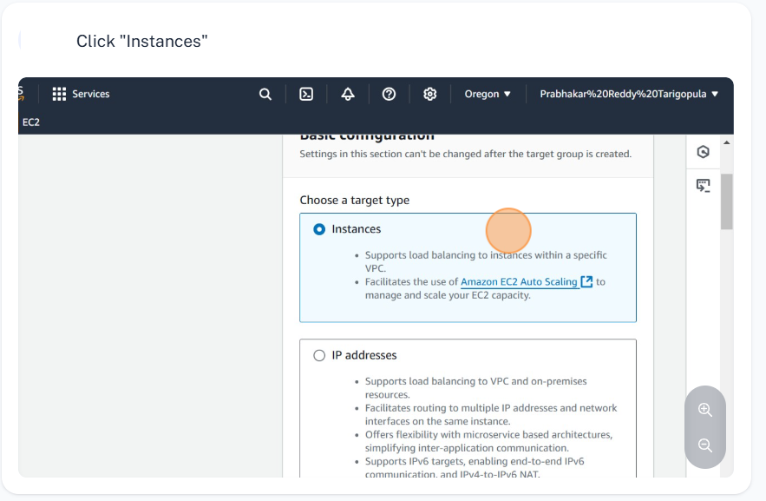

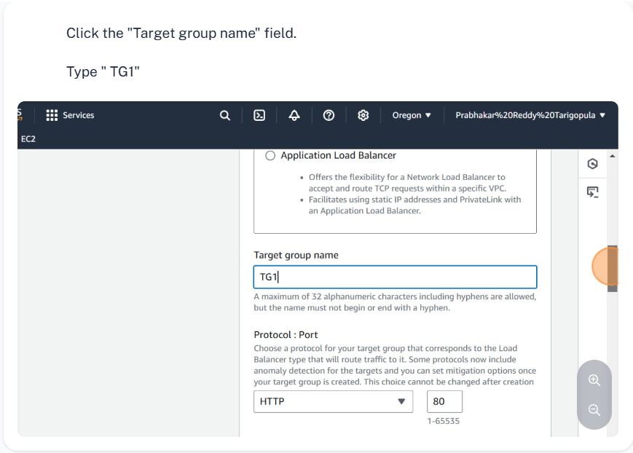

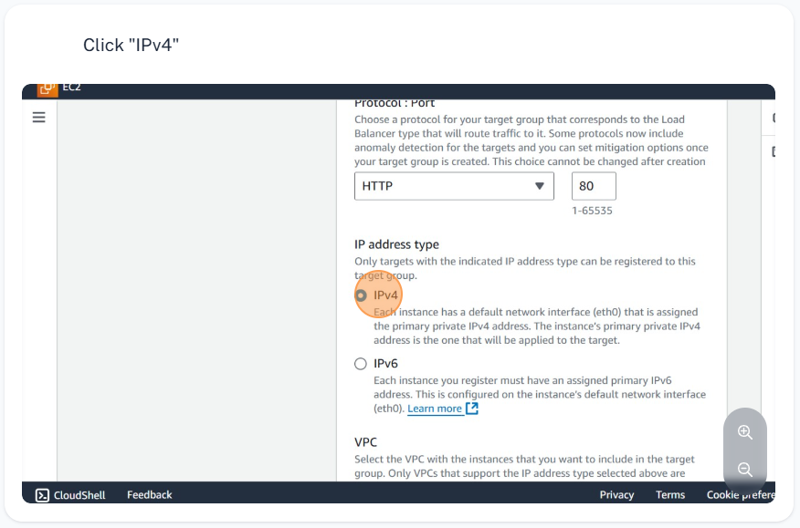

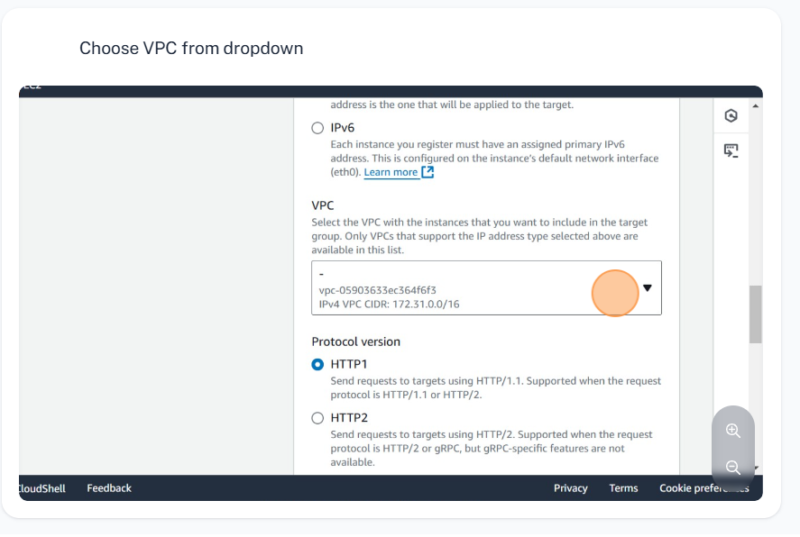

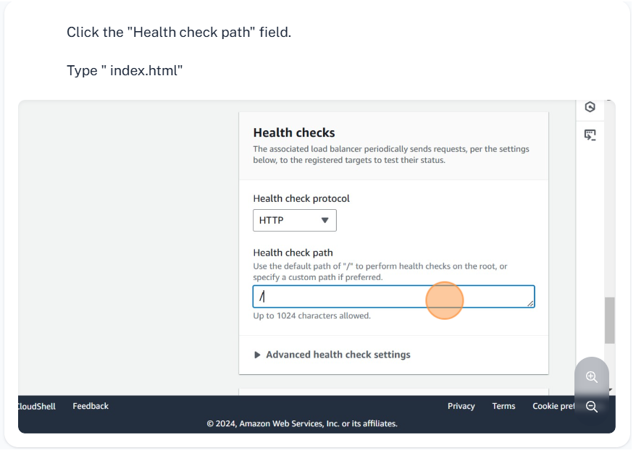

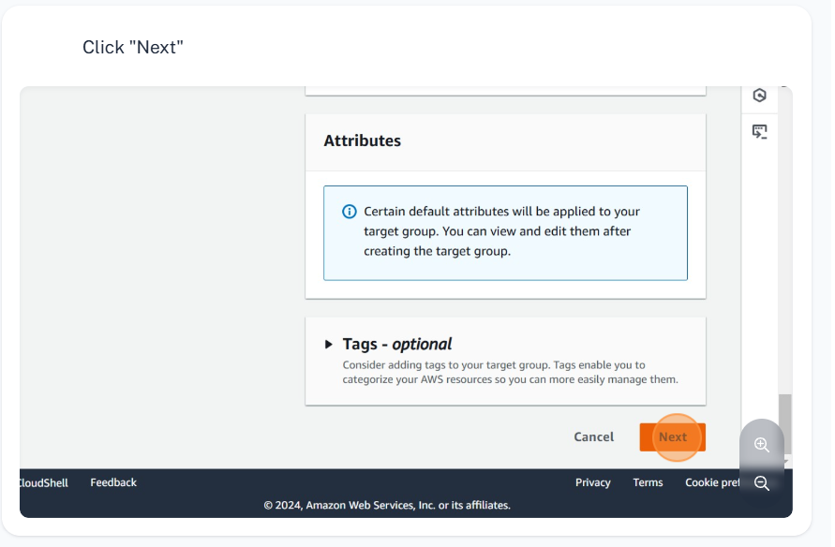

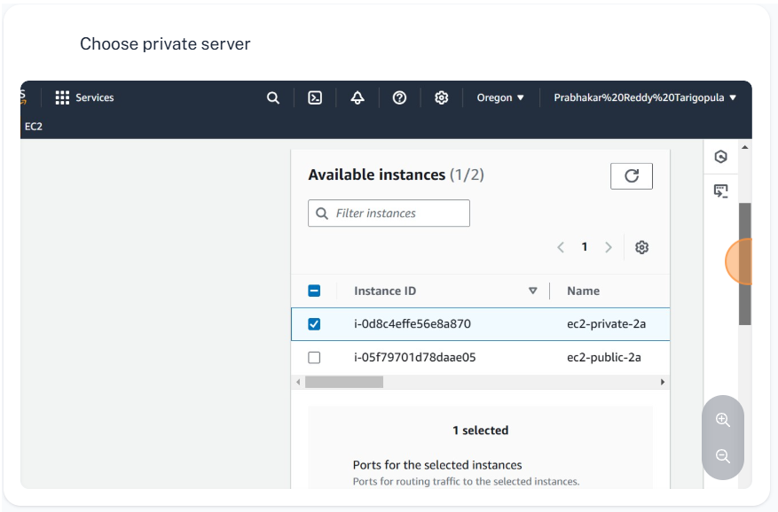

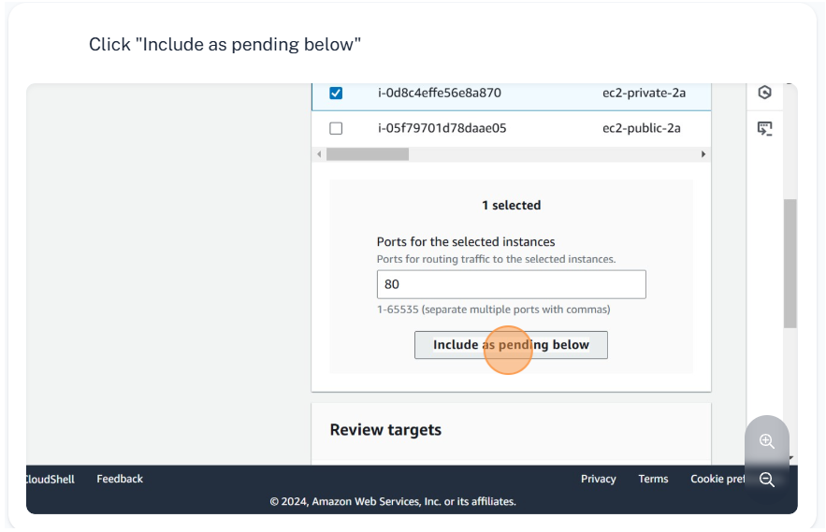

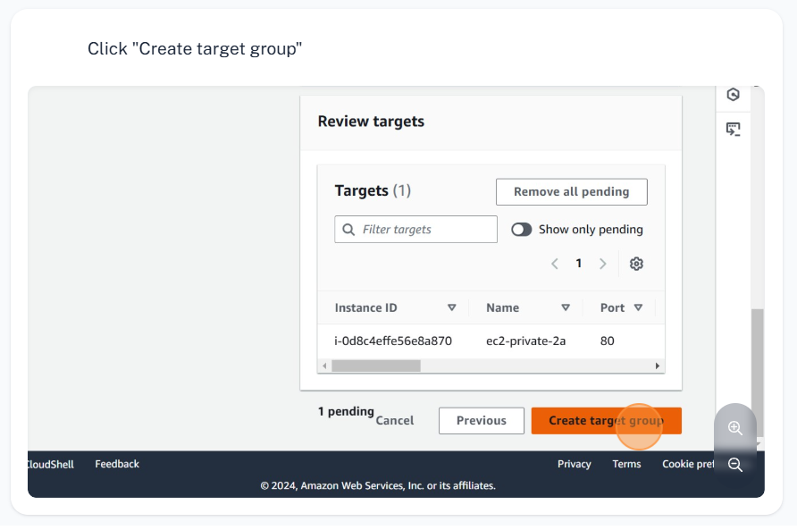

**Steps to configure load balancer**

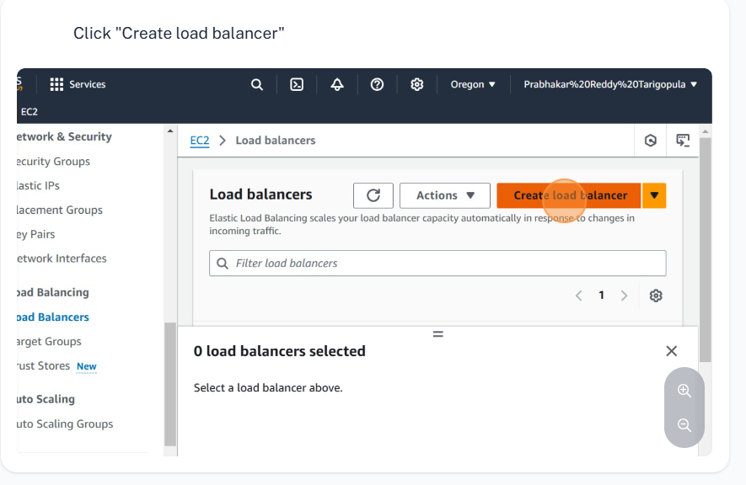

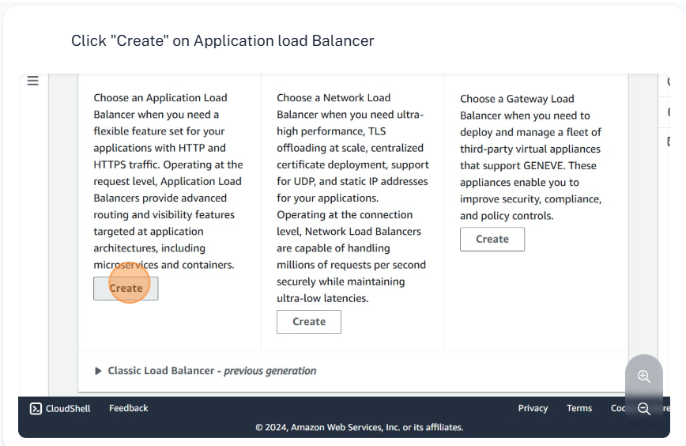

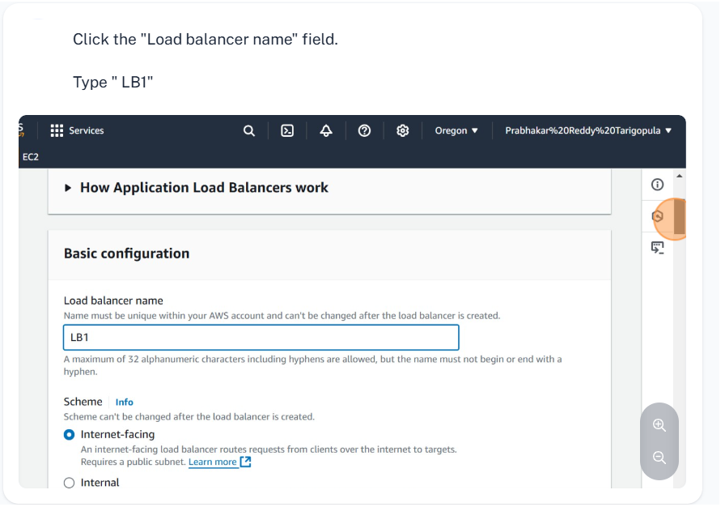

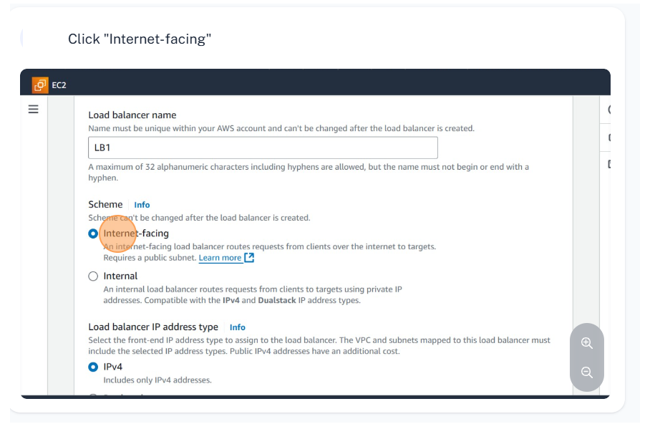

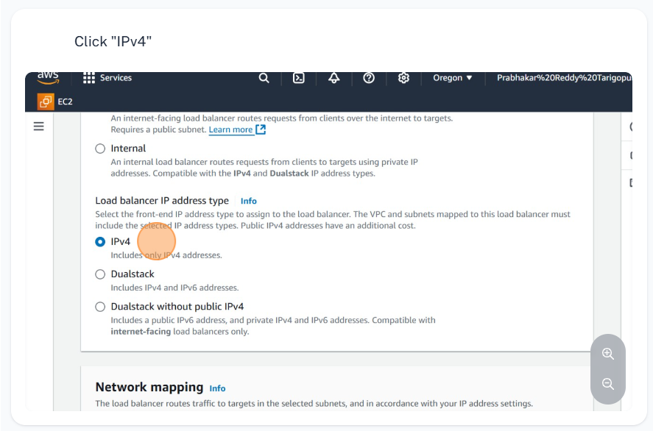

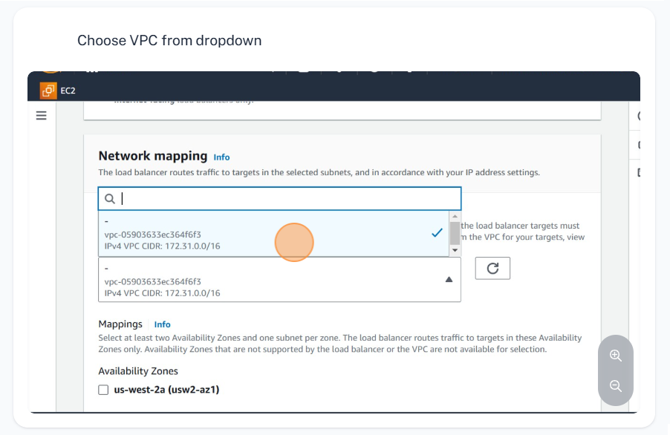

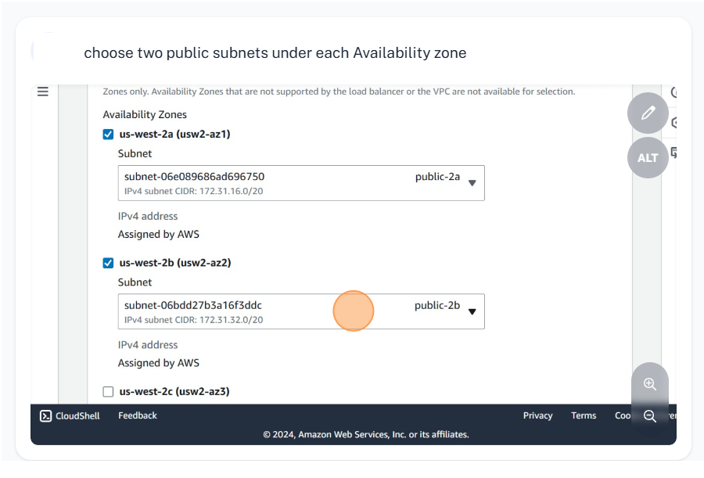

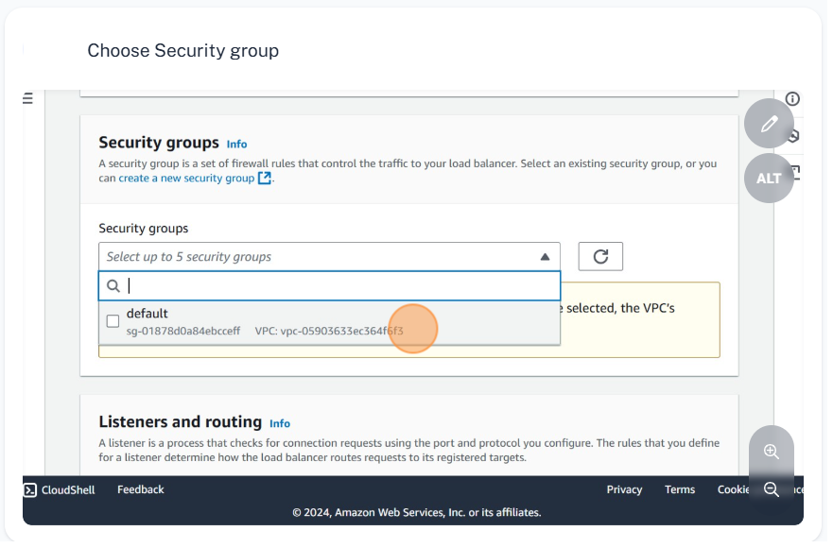

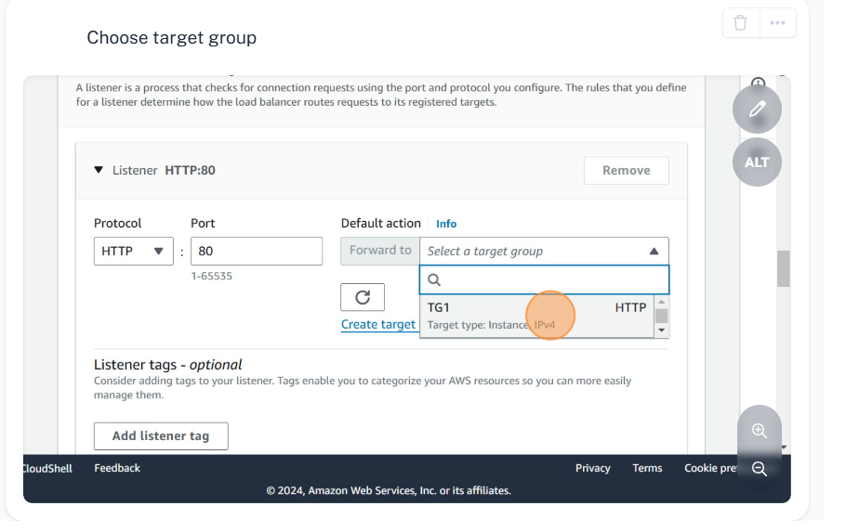

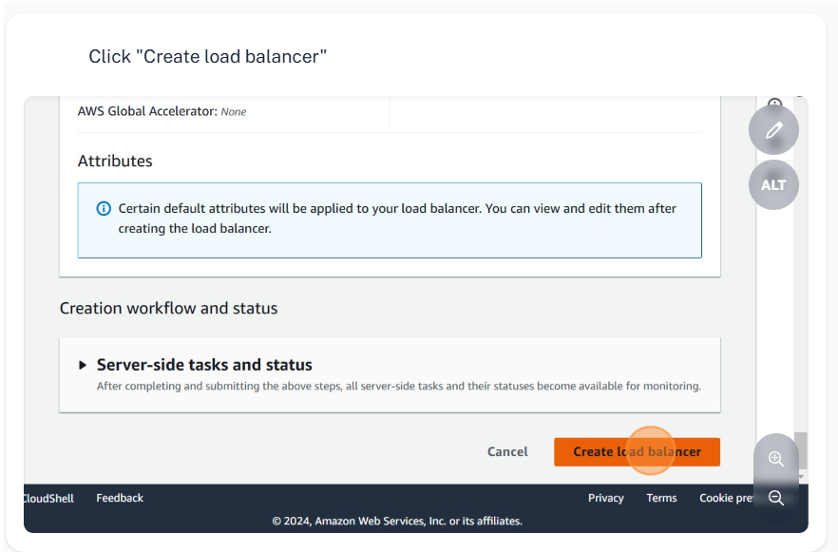

**Steps to access the index page created on private server**

**Open new tab and paste the DNS name**

